Exercise 1: Web Search

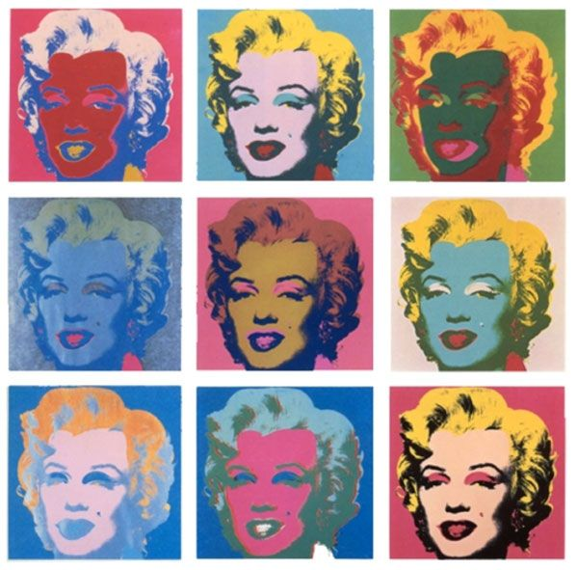This illustration uses unity, repetition, and variation by using the same picture over again, but changing the colors used. And using unity by keeping it in a grid shape.

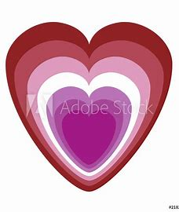 This graphic design uses unity and harmony. The overlapping shapes in the heart and the color scheme.

This photograph uses repetition and unity and harmony. It repeats the legs using the same shoes and socks. It has a shape using unity and harmony with it all going together.

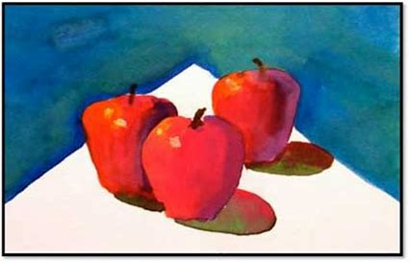This painting uses repetition and variation. It uses apples over again but has them overlap and in different shapes.

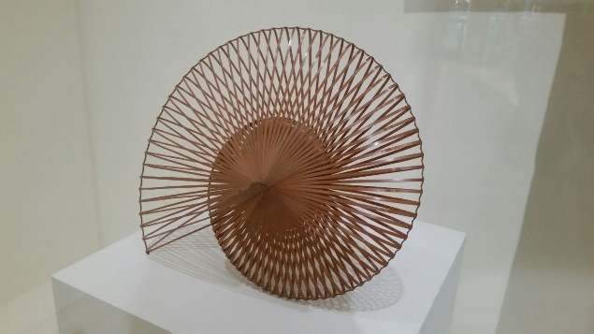This sculpture uses repetition and harmony. I repeats the same lines over and over, but is definitely satisfying to look at.